**lOGOS**

**MSP WEBSITE MASTER CONTENT**

**HOME | ABOUT MSP | SECTORS |MSP PROCESS | DATA PORTAL |RESOURCES |MEDIA |FEEDBACK|CONTACT US**

**Home>>**

**Home>>About MSP>>Background>>Global Context**

**Watch MSP video** 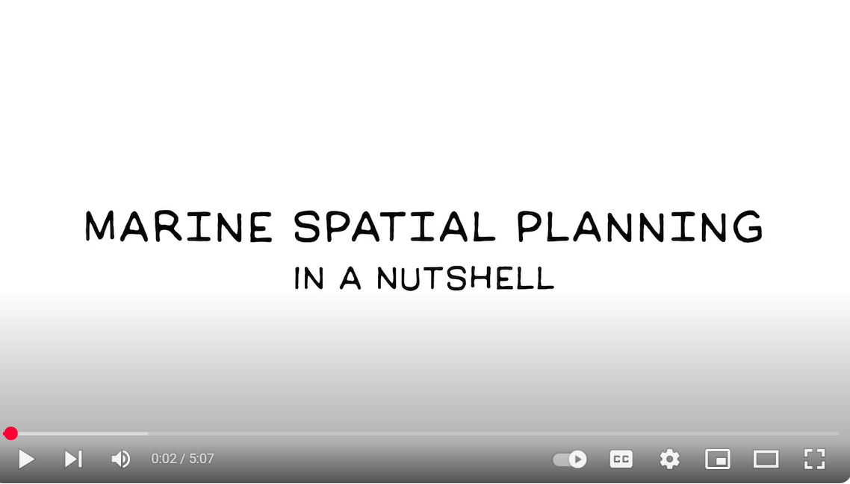

* English version
* Swahili version

**Download MSP Fact Sheets**

**What is Marine Spatial Planning (MSP)?**

Marine Spatial Planning (MSP) is a public process that systematically analyses and organises the distribution of human activities in marine areas to achieve clear ecological, economic, and social objectives.

As defined by [**UNESCO**](https://www.google.com/search?q=https://www.unesco.org/en/articles/marine-spatial-planning-tool-effective-ocean-management), MSP is a practical approach for a more rational use of marine space. It helps to balance the competing demands of development with the critical need to protect the environment, ultimately delivering social and economic benefits in a planned and transparent way through a participatory process.

This approach considers how various marine uses and activities are organized spatially, supporting integrated management and providing a mechanism to resolve potential conflicts. By working within existing legislation and policies, MSP creates a consultative platform for engagement and discussion among a wide range of stakeholders, including:

* National and county representatives
* Relevant agencies
* Coastal communities and local leaders
* Resource users and owners

MSP has emerged as a systematic way to integrate [ecosystem-based management](https://portals.iucn.org/library/sites/library/files/documents/2000-051.pdf) into multi-objective plans through a participatory, transparent, and equitable process. It is a comprehensive and strategic framework designed to:

* Minimize conflicts between human activities.
* Maximize benefits from marine resources.
* Ensure the resilience of marine ecosystems.

This involves using spatial measures, such as allocating specific areas for particular uses, setting conditions for resource use, and addressing the cumulative impacts of multiple sectors on the marine environment.

**Download MSP Factsheets**

* MSP Framework
* MSP Process
* Policy and Legal Issues
* See All Resources

**Home>>About MSP>>Background>>Kenya MSP Framework**

**National MSP Framework**

Determining the allocation of marine space for different uses and users requires a systematic, consistent, and robust process that is integrative, adaptive, and strategic. This can be achieved through a Marine Spatial Plan (MSP).

MSP has emerged as a systematic approach for harmoniously integrating the principles of ecosystem-based management into multi-objective plans through a participatory, transparent, and equitable process. It is cross-sectoral in nature, and thus, special consideration must be given to how sectors interact during the planning and designing of the plan, as well as in the implementation of the agreed action plans.

Kenya has started the process of developing a national Marine Spatial Plan (MSP) for the Territorial Waters, Exclusive Economic Zone (EEZ), and the Extended Continental Shelf (ECS), in line with the national development blueprint captured in the Fourth Medium Term Plan (MTP IV 2023 – 2027). This effort is guided by a national framework that provides the strategic direction and foundational principles for the MSP process, ensuring alignment with Kenya’s broader goals for sustainable development within the blue economy.

The MSP is expected to strategically align all the sectors of the blue economy to enable them to effectively and sustainably harness the coastal and marine resources for socio-economic development.

The MSP Framework is, therefore, intended to provide a comprehensive, transparent, and inclusive approach that promotes the sustainable harnessing of the blue economy for accelerated social and economic development.

The framework provides guidance on the planning, principles, and elements of MSP and a roadmap for the development, implementation, monitoring, and evaluation of the plan.

The Kenya MSP process is funded by the World Bank and the Government of Kenya through the Kenya Marine Fisheries and Socio-Economic Development ([KEMFSED](https://kemfsed.org/wp-content/uploads/2022/12/KEMFSED_TOR_FOR_MSP-_Marine_Spatial_Planning-09112022-with-WB-Procurement-Comments-RevRTS.pdf)) Project. It is implemented by the [Ministry of Mining, Blue Economy and Maritime Affairs](https://mibema.go.ke/) through the State Department for the Blue Economy and Fisheries working.

* [Link to MSP Framework](https://www.google.com/search?q=) full document
* [Link to MSP Framework Fact Sheet](https://www.google.com/search?q=)-English
* [Link to MSP Framework Fact Sheet](https://www.google.com/search?q=)-Swahili

**Home>>About MSP>>Governance Structure>>Institutional Framework**

**Governance and Coordination of Kenya's MSP**

The [Ministry of Mining, Blue Economy and Maritime Affairs](https://mibema.go.ke/) (MMBE&MA) coordinates the development of the Marine Spatial Plan (MSP). The MSP is implemented by State Department for the Blue Economy and Fisheries working in collaboration with the State Department for Maritime Affairs, [the State Department for Land and Physical Planning,](https://lands.go.ke/) and other government agencies.

Recognizing the broad, cross-sectoral nature of MSP, its development is supported by a multi-tiered governance structure to ensure comprehensive and collaborative oversight:

* **Executive Committee:** This high-level committee provides overall oversight for the MSP process. It is co-chaired by the Principal Secretaries from the State Department for the Blue Economy and Fisheries and the State Department for Shipping and Maritime Affairs. The committee's composition includes relevant Principal Secretaries, the Chair of the Council of Governors Blue Economy Committee, and other Chief Executive Officers.
* **Multi-Agency Steering Committee (MASC):** This committee, supported by various Technical Working Groups, is responsible for coordinating and spearheading the day-to-day MSP development process. It comprises representatives from all ministries, state departments, and agencies with mandates over marine spaces and resources.
* **MSP Secretariat:** Operating under the overall guidance of the State Department for The Blue Economy and Fisheries, and hosted by the [Kenya Marine and Fisheries Research Institute (KMFRI)](https://www.kmfri.go.ke/) the Secretariat provides administrative and technical support to the entire MSP process.

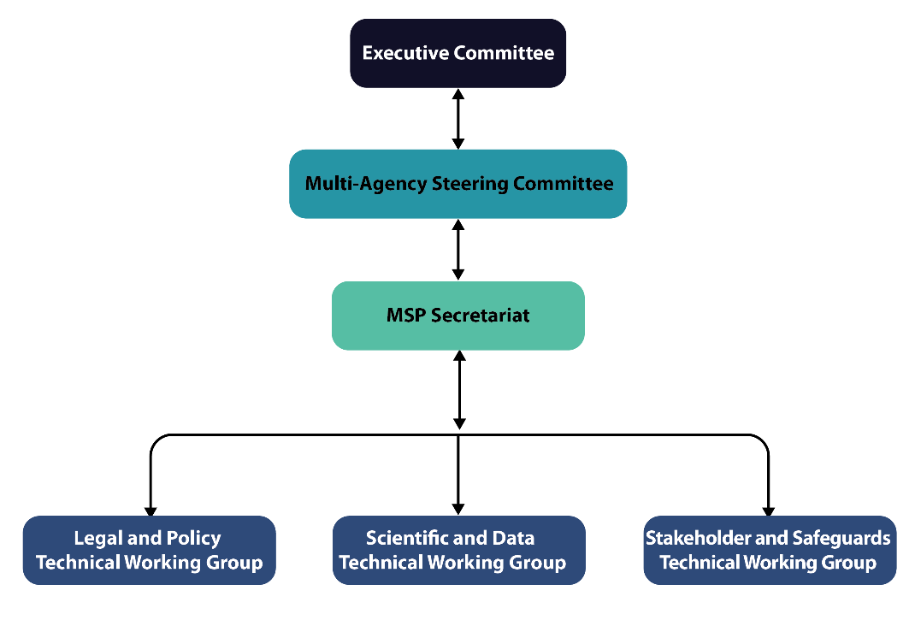

**Home>>About MSP>>Governance Framework>>Policy and Legal Framework**

**Policy and Legal Framework for MSP**

The [Fourth Medium Term Plan of Kenya Vision 2030](https://www.planning.go.ke/wp-content/uploads/2024/03/MTP-IV-2023-2027.pdf) identifies development of a Marine Spatial Plan as one of the tools to accelerate the growth of the Blue economy in Kenya by enabling sustainable use of the ocean space and marine resources.

Just like the terrestrial National Spatial Plan, the Marine Spatial Plan is guided by the [Constitution of Kenya](https://kenyalaw.org/kl/fileadmin/pdfdownloads/TheConstitutionOfKenya.pdf), which considers the country’s part of the ocean as part of land.

The MSP process is done under the [Physical and Land Use Planning Act](https://kenyalaw.org/kl/fileadmin/pdfdownloads/Acts/2019/PhysicalandLandUsePlanningAct_No13of2019.pdf) no. 13 of 2019, which the line ministry to plan, develop and formulate safe and efficient use of the Kenya ocean space.

In the context of devolution, the planning mandates of the National and County Governments is concurrent. The MSP is a national strategic plan that is complementary to lower-level plans developed by the counties. The county counties are consulted and participate in some aspects of the MSP process.

The MSP process also takes into account various other relevant policies and laws:

* [Sessional paper No. 1 of 2017](https://repository.kippra.or.ke/handle/123456789/489)on National Land Use Policy outlines measures by the government to ensure sustainable coastal environmental management and blue economy and recognizes that the Government shall ensure the formulation and implementation of an integrated coastal land use plan.
* Physical and Land Use Planning Act No. 13 of 2019 has provisions for planning, use, regulation and development of land. It establishes the planning authorities, provides for types of plans, process of preparation and approval as well as mechanisms for conflict resolution mechanism.
* Environment [Management and Coordination Act](https://kenyalaw.org/kl/fileadmin/pdfdownloads/Acts/EnvironmentalManagementandCo-ordination.pdf) (Cap 387), which requires that all policies and plans be subject to strategic environmental assessment.
* [Kenya Maritime Authority Act (Cap 370)](https://faolex.fao.org/docs/pdf/ken128260.pdf) provides for the function of the Authority to co-ordinate the implementation of policies relating to maritime affairs and promote the integration of such policies into the national development plan.

**Home>>About MSP>>Purpose and Objectives>>Purpose**

**Purpose of MSP**

Kenya's ocean space is a rich and diverse ecosystem, home to a wide range of natural features including coral reefs, mangrove forests, sandy beaches, seagrass beds, estuaries, and offshore zones. These ecosystems support a vast array of marine life, providing vital fisheries resources that are a source of food and income for the Kenyan people.

However, these valuable resources face significant threats from the triple planetary crises of climate change, pollution, and biodiversity loss. To protect and sustainably manage our ocean, a clear understanding of its natural characteristics and existing uses is essential.

This understanding is crucial for the planning process, enabling the strategic identification and allocation of marine areas for various activities, including:

* Biodiversity conservation and ecosystem preservation.
* Sustainable fisheries and aquaculture.
* Marine transport and energy development (renewable and non-renewable).
* Military installations, mining, tourism, sports, and cultural heritage.

The sustainable use of the ocean and its biodiversity depends on this appropriate planning and management.

**The purpose of the MSP****:**

To provide a marine spatial framework for integration and coordination of social-cultural, environmental and economic policies for accelerated development of the blue economy.

**Objectives**:

1. To provide a framework for an integrated approach to Marine governance, planning and sustainable conservation and management of coastal and marine resources.
2. To promote coordinated and integrated multi-sectoral planning and infrastructure development for optimization of marine opportunities and contribution to socio-economic development.
3. To facilitate collaboration among government agencies, county governments, coastal communities and other stakeholders in the management of the coastal and marine resources
4. To provide guidelines, standards and regulations on conservation and utilization of coastal and marine resources.

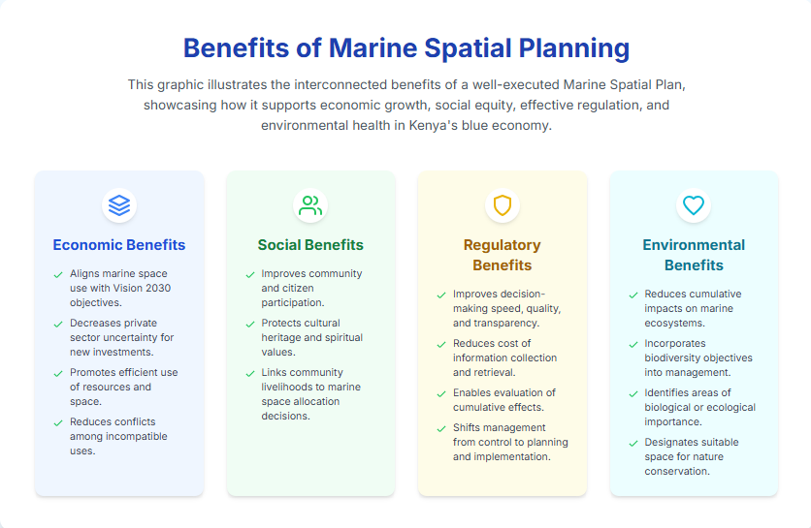

**Home>>About MSP>>Planning Area**

**Planning Area**

The Geographical Scope of the Marine Spatial Plan (MSP) planning area covers the land-sea interface, internal waters up to the high-water mark adjacent to coastal counties of Mombasa, Kwale, Kilifi, Tana River and Lamu, the territorial sea, Exclusive Economic Zone (EEZ) and the Extended Continental Shelf.

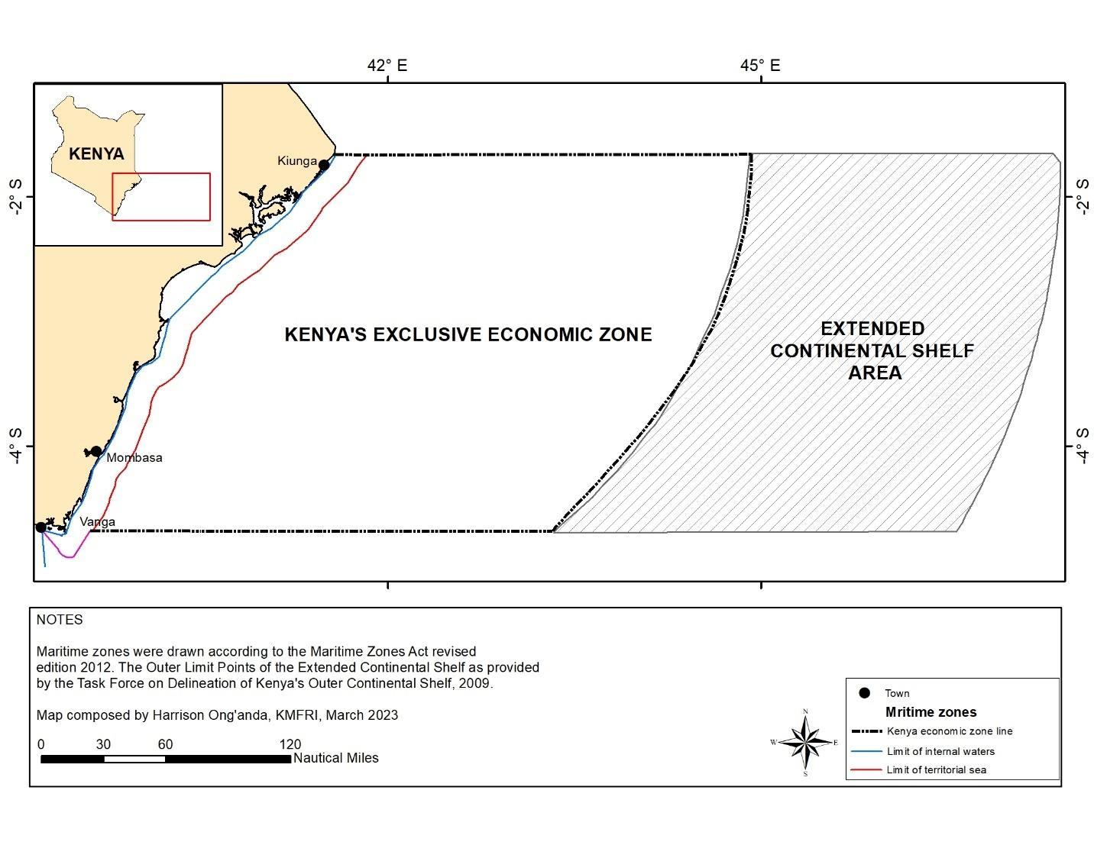

**Home>>About MSP>>Sectors>> Biodiversity & Conservation**

**Biodiversity & Conservation**

Kenya’s marine ecosystems are rich in biodiversity, hosting over 250 species of hard corals, more than 1,000 species of fish, and diverse mammals, sea turtles, and seabirds.

The [biodiversity](https://www.cbd.int/countries/profile?country=ke) and conservation thematic area focuses on the preservation and sustainable management of these ecosystems, which include over 61,000 hectares of mangrove forests, coral reefs covering 630 km², seagrass beds, estuaries, and intertidal zones.

These habitats provide essential ecosystem services such as carbon sequestration, shoreline protection, nursery grounds for fish, and cultural identity.

However, increasing pressures from climate change, coastal development, destructive fishing practices, and pollution have degraded many of these habitats.

* MSP will take into account the strategies being implemented to ensure long-term ecological health and resilience of these habitats include ecosystem-based management, establishment of [Marine Protected Areas (MPAs)](https://nairobiconvention.org/clearinghouse/mpa_dashboard_kenya), conservation of critical habitats and species, climate adaptation and blue carbon initiatives.

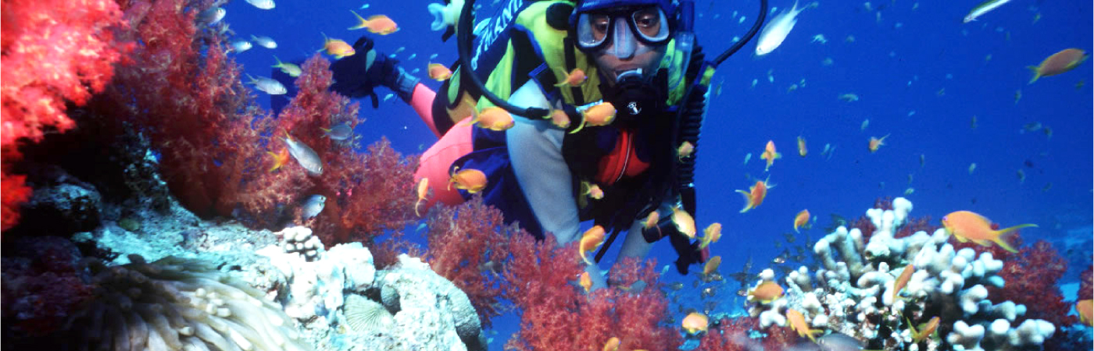

**Home>>About MSP>>Sectors>>Fisheries and Mariculture**

**Fisheries and Mariculture**

The fisheries sector in Kenya supports the livelihoods of [over 27,000](https://www.researchgate.net/publication/350873853_Contribution_of_Fisheries_to_Job_Creation_Among_the_Youth_in_Kenya) artisanal fishers and many more in related value chains. In 2023, marine capture fisheries contributed about 39,950 metric tonnes of fish valued at [KES 9.9 billion](https://kefs.go.ke/sites/default/files/2024-09/FISHERIES%20ANNUAL%20STATISTICS%202023_.pdf?utm_source=chatgpt.com), with key species including tuna, snapper, and sardines.

Despite its immense value, the sector faces challenges such as overfishing, habitat destruction and conflicts between artisanal and industrial actors.

MSP identifies fisheries and mariculture as a key thematic area to address spatial conflicts, ensure sustainable fishing zones and promote co-management systems.

There is also a growing focus on developing mariculture, such as seaweed, shellfish, and finfish farming, to diversify livelihoods and reduce pressure on wild stocks. Spatial planning can allocate mariculture zones, enhance water quality, and minimize user conflicts.

The key aspects to be considered in the MSP include:

* Artisanal, commercial, and sport fishing
* Sustainable mariculture zoning
* Fisheries co-management and enforcement
* Reduction of illegal, unreported, and unregulated (IUU) fishing

#### 

**Home>>About MSP>>Sectors>>Energy and Mineral Resources**

**Energy and Mineral Resources**

Kenya’s marine and coastal zone has growing potential for [offshore energy](https://nairobiconvention.org/clearinghouse/sites/default/files/Coastal%20and%20Offshore%20Oil%20and%20Gas%20and%20Renewable.pdf) and mineral development. Oil and gas exploration has occurred in Blocks L4, L5, L6, L7, L10A, L10B, L11A, and L11B off the Lamu coast, although no commercial production has started. The country is also exploring renewable energy sources such as [offshore wind](https://documents1.worldbank.org/curated/en/374301586851976191/pdf/Technical-Potential-for-Offshore-Wind-in-Kenya-Map.pdf), wave, and [tidal energy](https://www.renewableenergy.go.ke/tidalenergy.html). Renewable energy already accounts for over 80% of national electricity generation.

The coast is also a key source of construction materials such as sand and coral rock, which are often extracted unsustainably.

* MSP promotes coordinated and environmentally responsible exploitation of marine-based energy and mineral resources.
* MSP facilitates spatial mapping of resource potential, impact assessments, and harmonization with conservation and community interests.

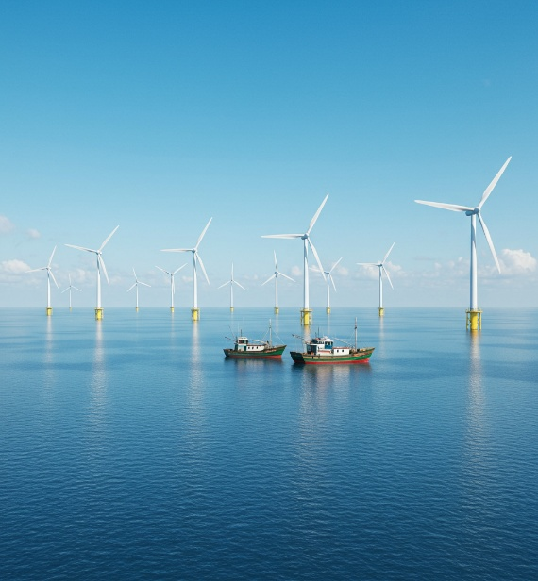

**Home>>About MSP>>Sectors>>Transport and Infrastructure**

**Transport & Infrastructure**

Kenya’s maritime transport and infrastructure are pivotal, underpinning national and regional trade. The [Port of Mombasa](https://www.ttcanc.org/maritime-port-mombasa), handling over 34 million tonnes of cargo annually, connects to more than 80 ports worldwide. [The Lamu Port](https://lapsset.go.ke/lamu-port/), a significant greenfield investment under the [LAPSSET](https://lapsset.go.ke/lamu-port/) corridor, is poised to enhance regional connectivity with 32 planned berths.

[Smaller ports](https://www.kpa.co.ke/OurBusiness/Pages/Small-ports.aspx) like[Shimoni](https://www.kpa.co.ke/SitePages/PortofShimoni.aspx), Funzi, Vanga, Kilifi, Malindi, and Kiunga are being upgraded to bolster fisheries and blue economy activities, with Ngomeni and Takaungu identified for future development.

This thematic area encompasses maritime transport networks, shipping lanes, port expansions, navigational safety, and intermodal transport integration.

* MSP will support sustainable ocean use by mapping and guiding the establishment of maritime infrastructure, including ports, jetties, shipping routes, shipyards, oil terminals, ferry lines, anchorage zones, undersea cables and pipelines, marinas, navigational aids, and restricted security areas.
* MSP will also facilitate efficient assignment of sea routes to reduce emissions, manage anchorages, and ensure infrastructure development does not compromise sensitive ecosystems. With growing maritime traffic, there is a strong emphasis on minimizing oil spills, ballast water contamination, and physical damage to coral reefs and seagrasses.

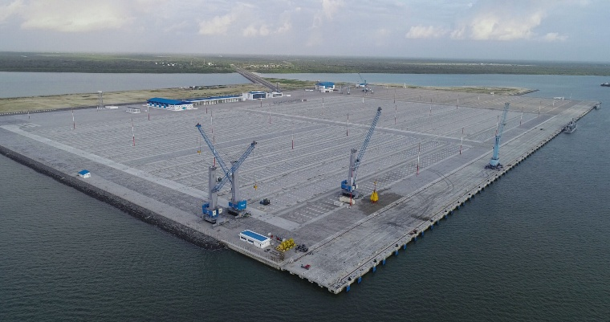

**Home>>About MSP>>Sectors>>Tourism, Sports, and Recreation**

**Tourism, Sports, and Recreation**

Coastal and marine tourism is a vital part of Kenya’s economy, especially in counties like Mombasa, Kwale, Kilifi, and Lamu. Tourism contributes nearly 10% to Kenya’s GDP and directly employs over 1 million people nationally.

Coastal attractions include sandy beaches, coral reefs, marine parks such as [Kisite-Mpunguti](https://www.kws.go.ke/kisite-mpunguti-marine-park-reserve) and Watamu, and Swahili heritage sites. Recreational activities like snorkelling, scuba diving, sport fishing, and boat tours are popular with both domestic and international tourists.

However, unregulated tourism, overdevelopment, and poor waste management threaten ecological integrity and community access.

* MSP seeks to spatially plan and zone tourism activities, promote eco-certification schemes, safeguard aesthetic and cultural values, and ensure equitable benefit-sharing with coastal communities.

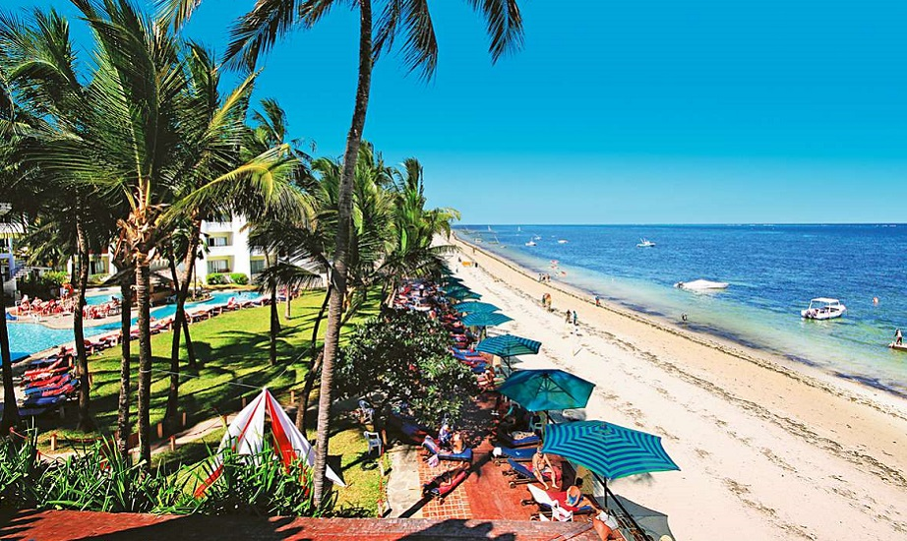

**Home>>About MSP>>Sectors>>Cultural Heritage**

**Cultural Heritage**

The Kenyan coast is home to centuries of cultural heritage, including ancient Swahili settlements, historic trade routes, and sacred sites.

[Lamu Old Town](https://whc.unesco.org/en/list/1055/), a UNESCO World Heritage Site, exemplifies this rich legacy. Many coastal communities practice traditional fishing, boat-building, and religious customs linked to the ocean.

However, cultural sites are increasingly at risk from coastal erosion, unplanned development, and neglect.

This thematic area highlights the need to protect both tangible cultural assets such as historical ruins, shipwrecks and mosques, as well as intangible heritage including oral histories and traditional knowledge.

MSP seeks to integrate cultural mapping into marine planning, involving custodians of heritage in decision-making, and supporting cultural tourism and education.

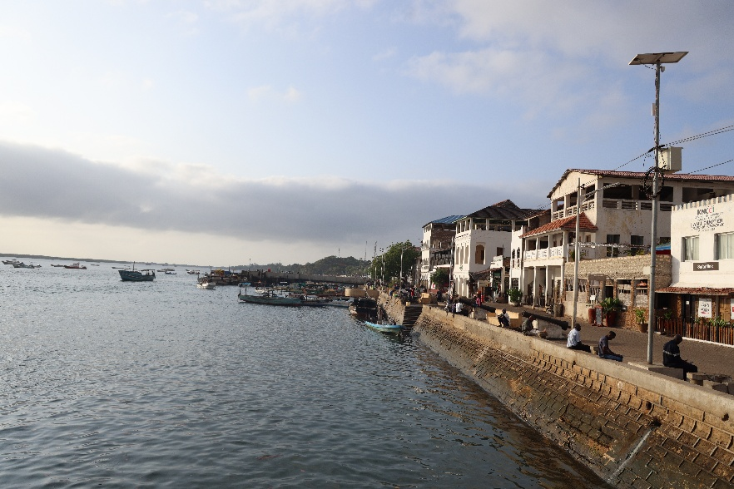

**Home>>About MSP>>Sectors>>Maritime Safety, Security & Defence**

**Maritime Safety, Security and Defence**

Maritime security is essential for protecting Kenya’s marine resources, national sovereignty, and blue economy investments. Kenya’s Exclusive Economic Zone (EEZ) spans over 230,000 km², making surveillance and enforcement a logistical challenge. Issues such as illegal fishing (IUU), drug and human trafficking, piracy, and pollution require coordinated action.

This thematic area supports the strategic deployment of the Kenya Coast Guard Service (KCGS), Navy, and other agencies to ensure safe and secure maritime operations. It also addresses marine search and rescue (SAR), early warning systems, and disaster response mechanisms.

* The MSP process promotes the spatial designation of military zones, shipping safety corridors, and no-go zones in alignment with international maritime safety regulations.

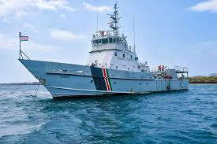

**Home>>About MSP>>Sectors>>Oceanography**

**Oceanography**

**Oceanography** is a core thematic area in Kenya’s Marine Spatial Planning. It provides essential scientific data on ocean currents, tides, waves, water quality, sea surface temperature, salinity, and seabed features. This information supports marine resource management, maritime safety, and climate change adaptation.

Kenya relies on institutions like the Kenya Marine and Fisheries Research Institute ([**KMFRI**](https://www.kmfri.go.ke/)**)** and international partners to generate and share oceanographic data, ensuring that marine spatial plans are evidence-based, adaptive, and aligned with ecosystem-based management.

In MSP oceanographic data help in:

* Zoning and habitat mapping to support sustainable use and protection of marine ecosystems
* Identifying suitable areas for activities such as aquaculture, port development, marine.
* Supporting early warning systems for storm surges, sea-level rise, and coastal erosion, enhancing coastal resilience and safety

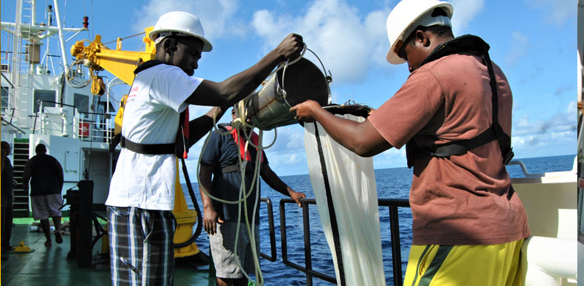

**Home>>About MSP>>Sectors>>Ocean Governance**

**Ocean Governance**

Effective ocean governance is the foundation of MSP and ensures integrated, equitable, and science-based management of marine spaces. Kenya’s ocean governance involves a complex web of institutions, including the [State Department for the Blue Economy and Fisheries](https://www.mibema.go.ke/node/107), Kenya Ports Authority, Kenya Fisheries Service, National Environment Authority, Kenya Marine and Fisheries Research Institute as well as the county governments, each with overlapping mandates.

This thematic area focuses on strengthening coordination, harmonizing policies and laws, enhancing stakeholder participation, and building institutional capacity. It also supports transparent decision-making, access to spatial data, conflict resolution, and monitoring and evaluation frameworks.

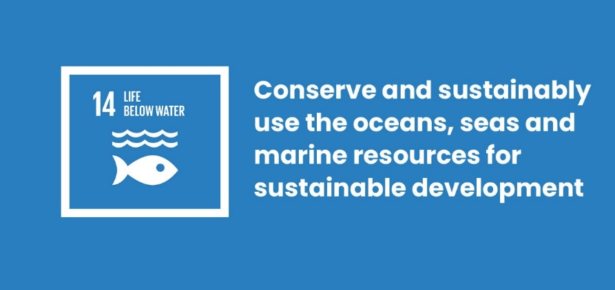By improving governance, Kenya aims to meet its obligations under the United Nations Convention on the Law of the Sea ([UNCLOS](https://www.un.org/depts/los/convention_agreements/texts/unclos/UNCLOS-TOC.htm)), the Sustainable Development Goals (especially SDG 14), and the [African Union’s 2050 Africa’s Integrated Maritime Strategy (AIMS).](https://au.int/sites/default/files/newsevents/workingdocuments/33832-wd-african_union_3-1.pdf)

**Home>>About MSP>>Sectors>>MSP Process**

**The Marine Spatial Planning Process for Kenya**

The process for development Kenya's national Marine Spatial Plan (MSP) involves seven key phases based on international best practices.

**Phase 1: Initiation & Financial Preparedness**

The MSP process is a significant and resource-intensive undertaking. Before initiation, a comprehensive scoping report was conducted to evaluate Kenya's readiness, assessing the availability of financial resources, infrastructure, human capacity, and the necessary legal and institutional frameworks. This assessment confirmed that Kenya possesses the capacity to successfully conduct marine spatial planning.

**Phase 2: Establishing Planning & Governance Teams**

To ensure a robust and well-coordinated process, a hierarchical governance structure is established. This government-led process identifies planning teams and a multi-tiered decision-making structure. These teams, comprising representatives from relevant government ministries, agencies, and state departments, have clear mandates for scientific, technical, legal, and stakeholder engagement tasks.

**Phase 3: Stakeholder Engagement Strategy**

A comprehensive Stakeholder Engagement Strategy (SES) and Communication Plan are developed to ensure all voices are heard. This is guided by Kenya's legal framework on public participation. The strategy ensures continuous involvement of key sectors like fisheries, tourism, and energy, with a specific focus on gender mainstreaming and the inclusion of vulnerable and marginalized groups (VMG).

**Phase 4: Scenario Analysis & Zonation**

The planning process covers territorial waters, the Exclusive Economic Zone (EEZ), and the Extended Continental Shelf (ECS), considering both current and future activities. This phase involves developing spatial and policy scenarios to build awareness about the consequences of different decisions. Through extensive stakeholder engagement, a consensus is reached on the zoning of different areas for specific uses.

**Phase 5: Strategic Environmental & Social Assessment (SESA)**

A Strategic Environmental and Social Assessment (SESA) is conducted to evaluate potential impacts of the plan. This participatory assessment identifies and addresses negative impacts while promoting positive outcomes. It covers impacts on biodiversity, sensitive habitats, ecosystems, and local community livelihoods, and is carried out in partnership with the National Environmental Management Authority (NEMA).

**Phase 6: Plan Development**

The Marine Spatial Plan is developed as a hybrid process, led by the government with consultant support. Developed per the Physical Land Use Planning Act (PLUPA), 2019, it culminates in a comprehensive, strategic document. This final plan integrates principles, goals, and data from previous steps into a roadmap, guiding implementation and continuous revision of the spatial vision.

**Phase 7: Approval & Implementation**

The plan's approval involves endorsement by the Inter-Ministerial Committee, submission to the National Security Council, and final approval by the Cabinet Secretary for Lands and Physical Planning. Once approved, the plan, valid for 10 years, will be implemented through activity licensing and the development of specific spatial regulations and guidelines for different sectors.

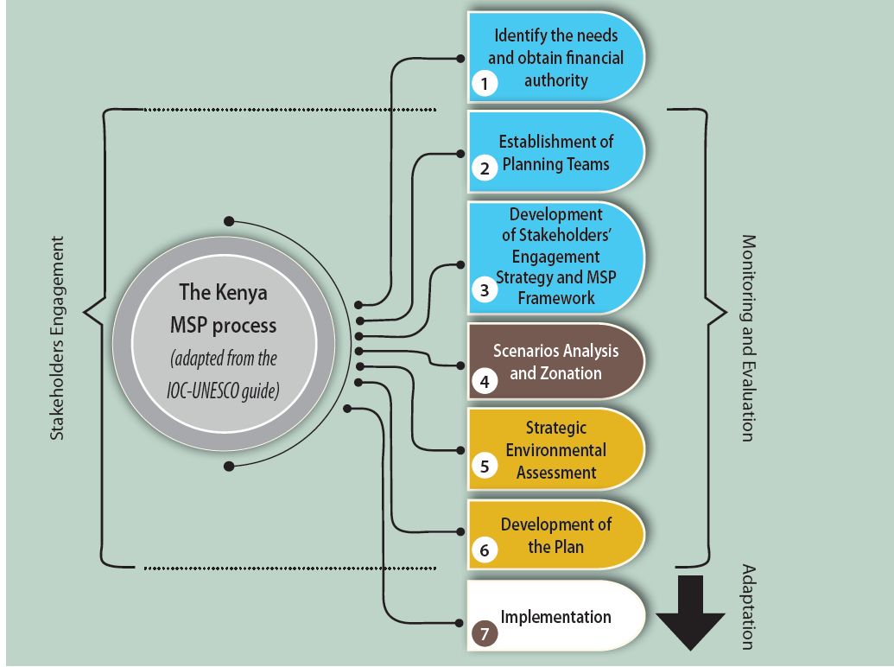

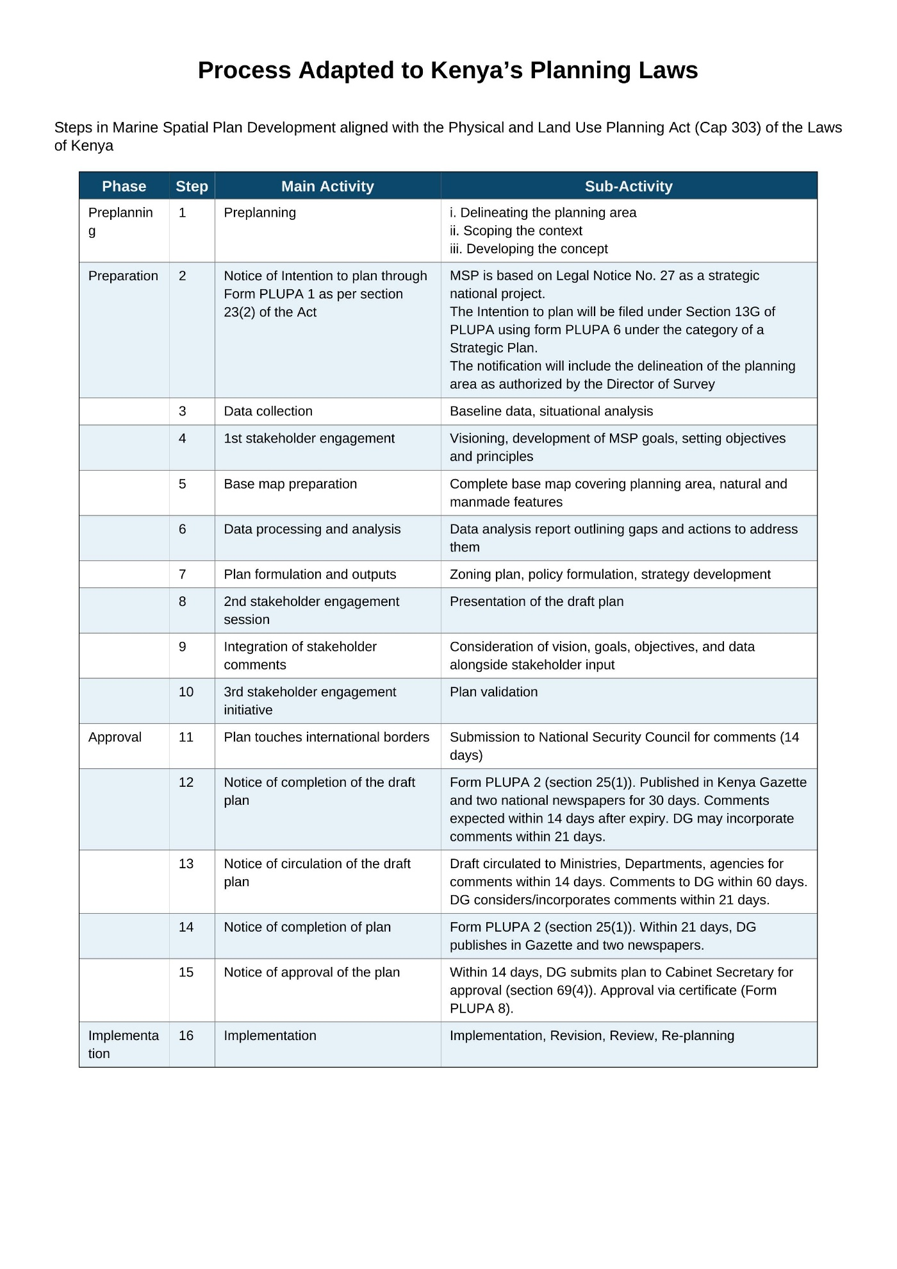

**Home>>About MSP>>Sectors>>MSP Process>>Data Portal>>**

**Kenya MSP Data Portal**

[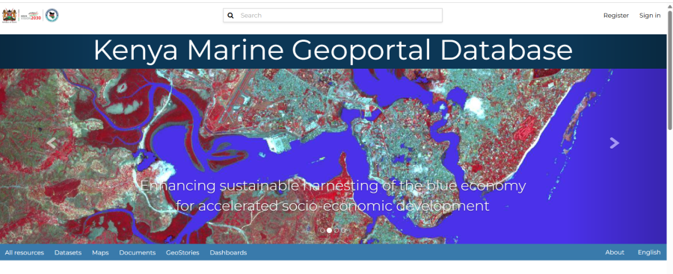](https://portal.msp.go.ke/)The Kenya Marine Atlas is a portal that provides diverse datasets and products related to the Marine Spatial Plan (MSP).

* Explore the data available to gain insights and support decision-making processes for development of Kenya’s MSP.

You can also the access:

* MSP maps and other products
* MSP planning tools and resources

[**CLICK here to access data portal**](https://portal.msp.go.ke/#/)

**Home>>About MSP>>Sectors>>MSP Process>>Data Portal>>Resources**

**MSP Data Portal -Kenya Marine Atlas**

The National Marine Spatial Planning (MSP) Framework provides guidance on the planning, principles, and elements of MSP and a roadmap for the development, implementation, monitoring, and evaluation of the plan.

* [**MSP Framework**](https://www.google.com/search?q=) - full document
* [**MSP Framework Fact Sheet**](https://www.google.com/search?q=) - English
* [**MSP Framework Fact Sheet**](https://www.google.com/search?q=) - Swahili

**Project Reports**

**Technical Reports**

* *Kenya Scoping Study*

**MSP Fact Sheets >>English**

*List all English*

**MSP Fact Sheets >>Swahili**

*List all Swahili*

**Presentations**

**Newsletter**

* Issue No 1

**Videos**

**Photo gallery**

**Useful websites**

* [MSP Global](https://www.mspglobal2030.org/resources/msp-global-documents/)

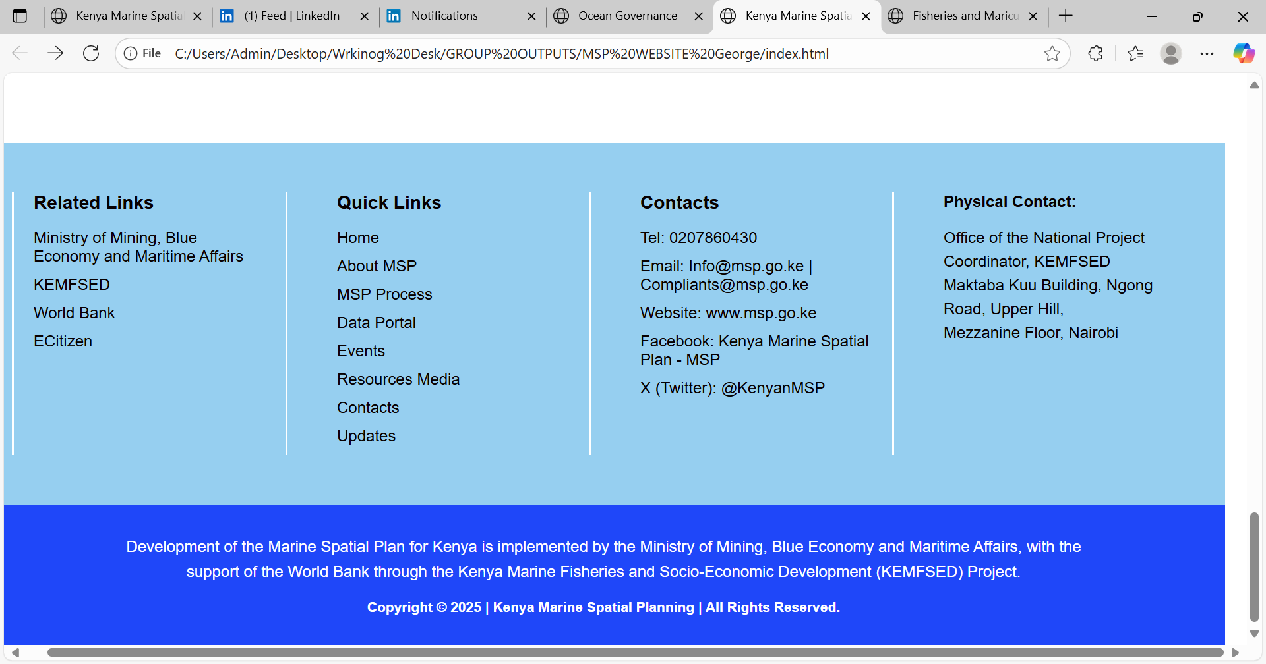**Website footer**

**Web Designer’s Resources**

1. **Uploads Tracking Sheet – excel sheet**
2. **Folders**

**- Master website Content**

**- Images**

**- Documents for Upload**